Ex.No: 6b | DATA VISUALIZATION USING POWER BI-  RETAIL SALES DATA
Date :

AIM
To import, transform, analyze, and visualize data using Power BI Desktop and create interactive dashboards and reports for decision-making.

ALGORITHM :
- Open Power BI Desktop
- Importing Data set into Power BI
- Select Transform Data , Remove duplicates and Handle null values
- Creating a Bar Chart, Pie Chart, KPI card, Slicers, DAX Calculations
- Creating Final Dashborad for Retail Dataset
OUTPUT :

Importing Data into Power BI :

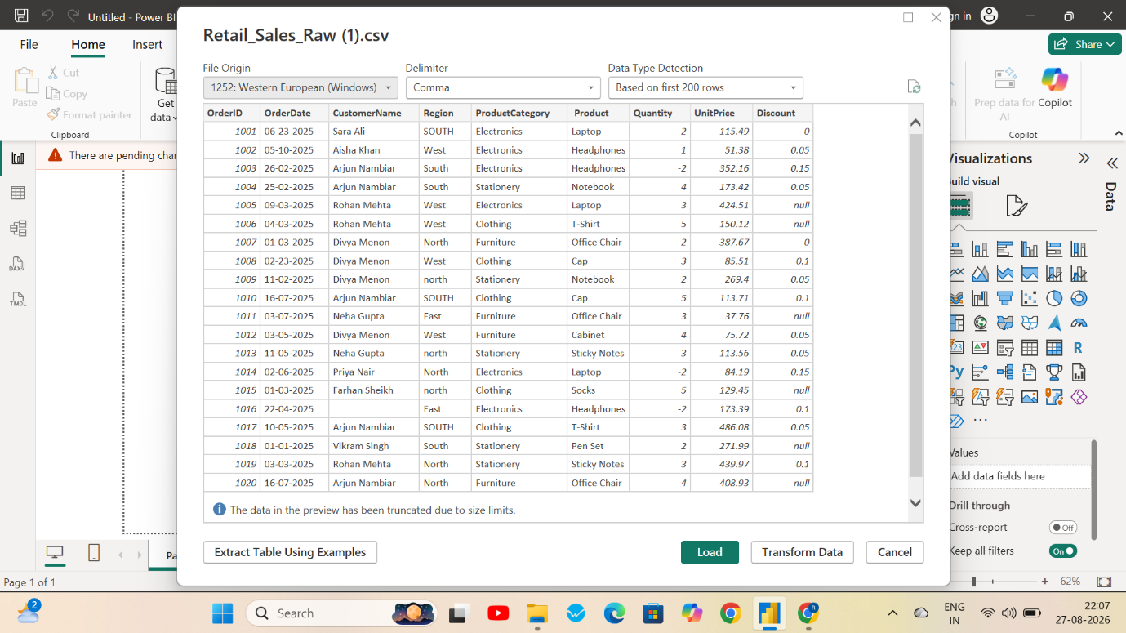

Handling Missing Values :
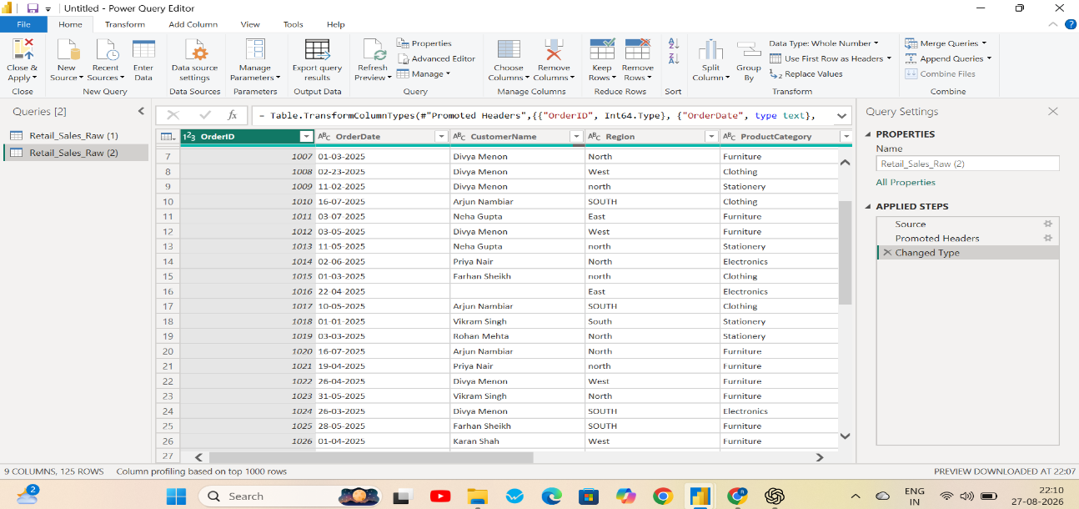

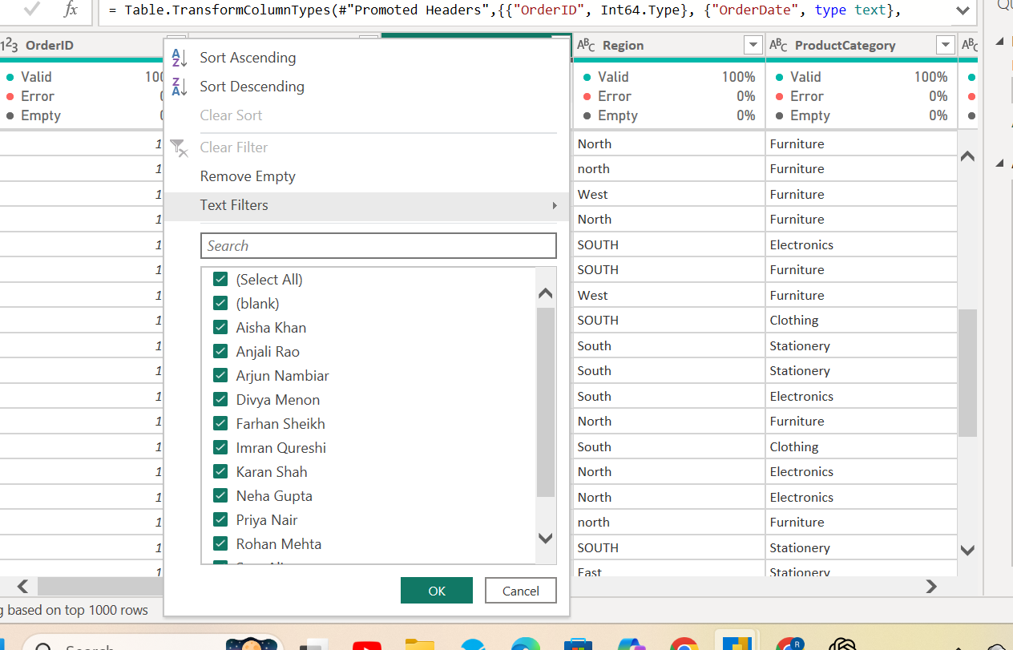

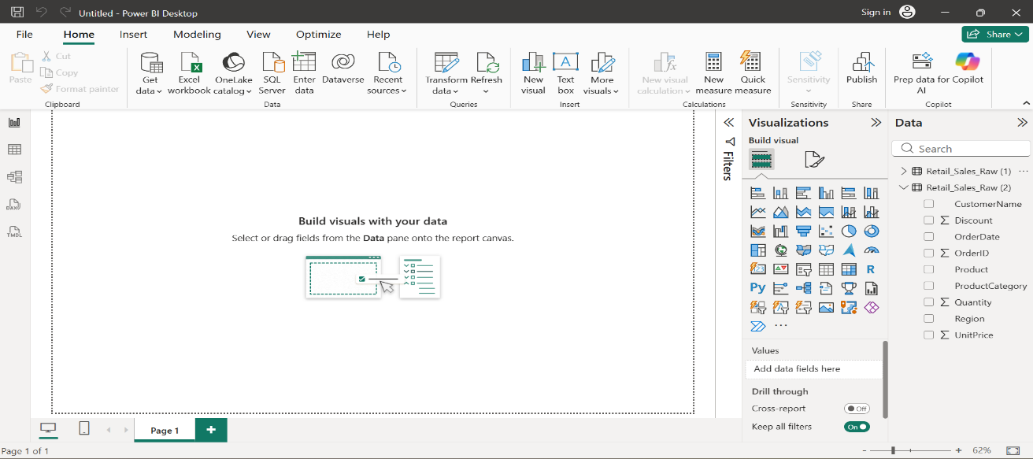
Creating Bar Chart – Total Quantity by Product
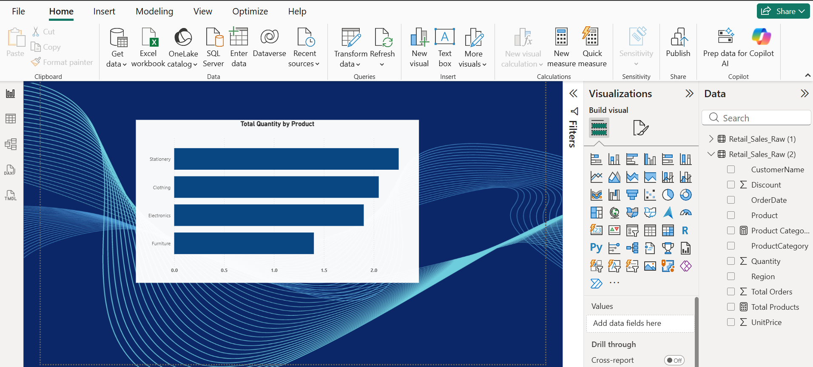
Creating Pie Chart- Sum of Unit Price by Product
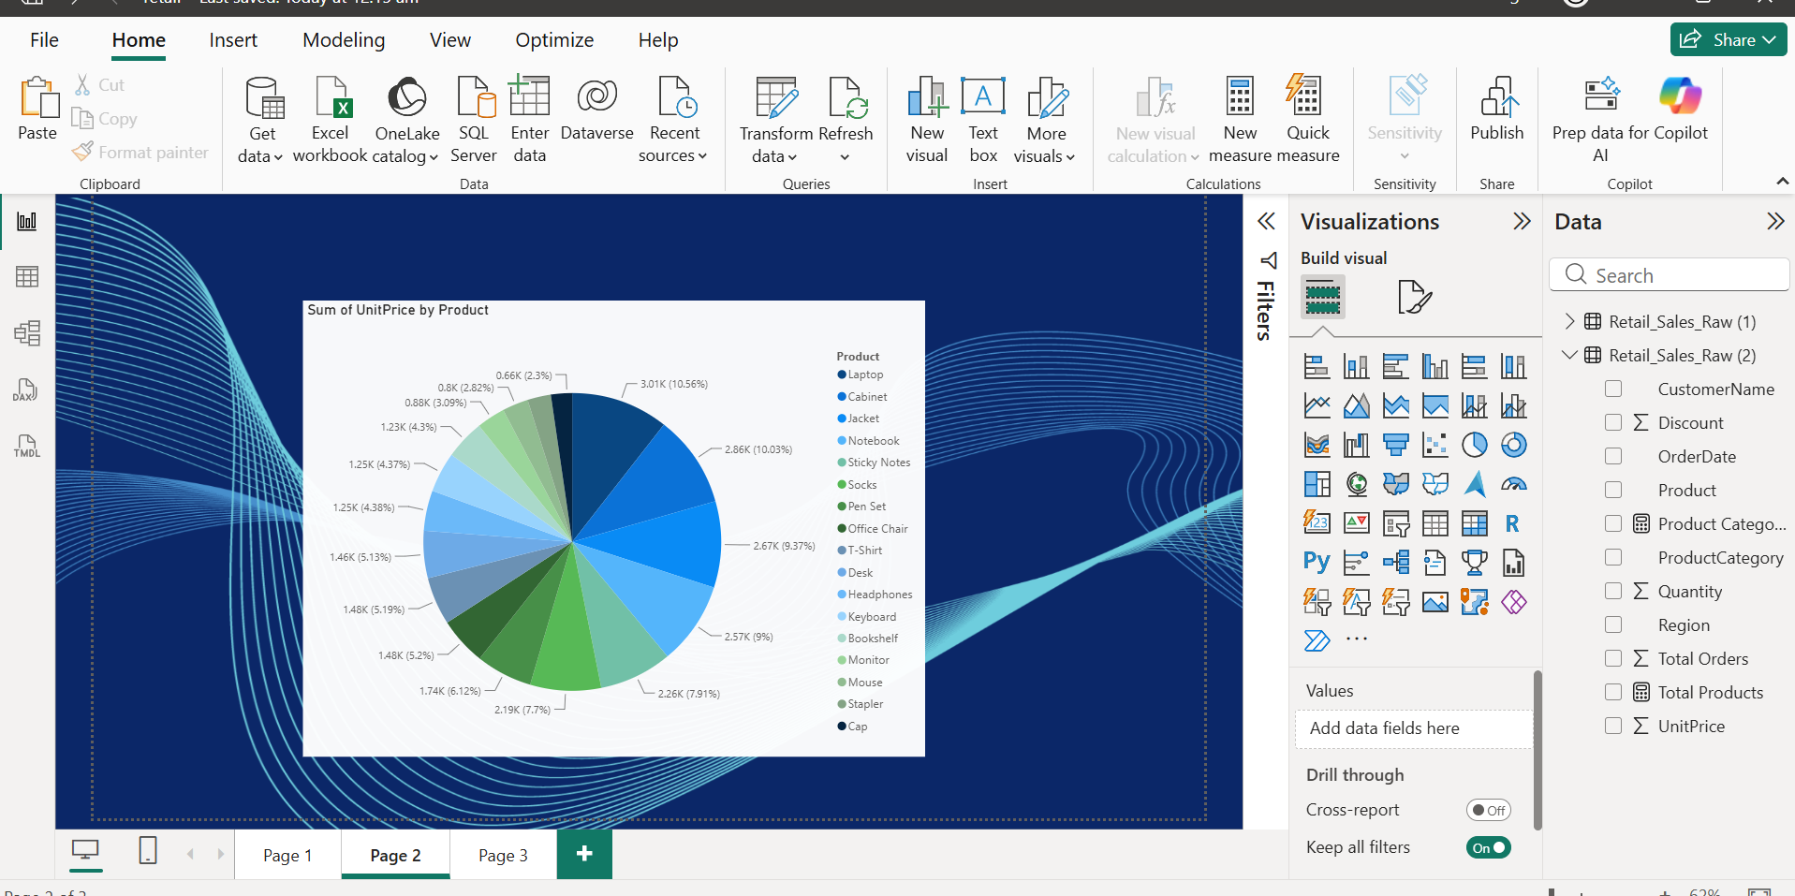
Creating Slicers-Total Quantity by Product
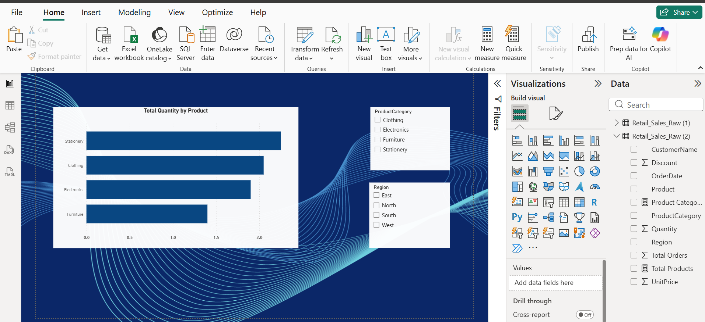
Creating KPI Cards using DAX Calculations:
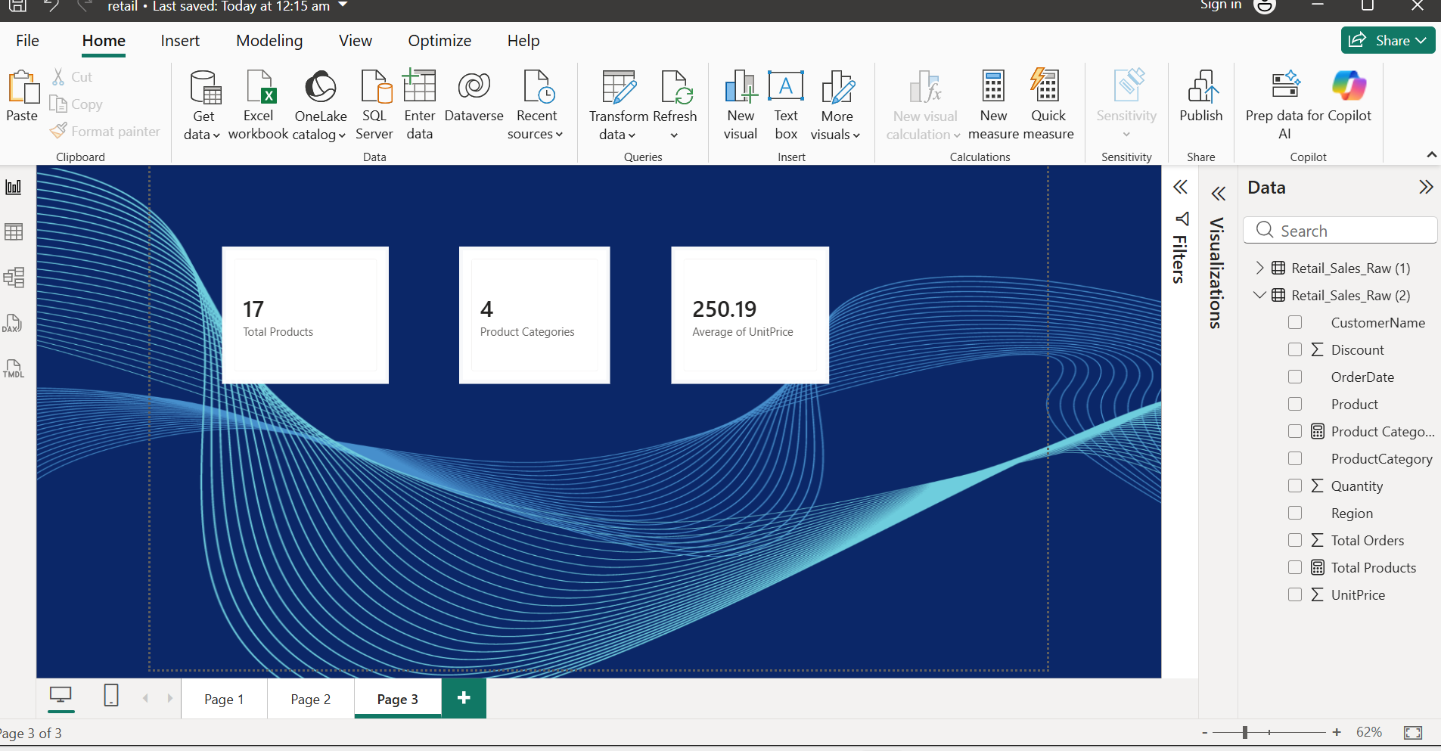
Creating Dashboard :
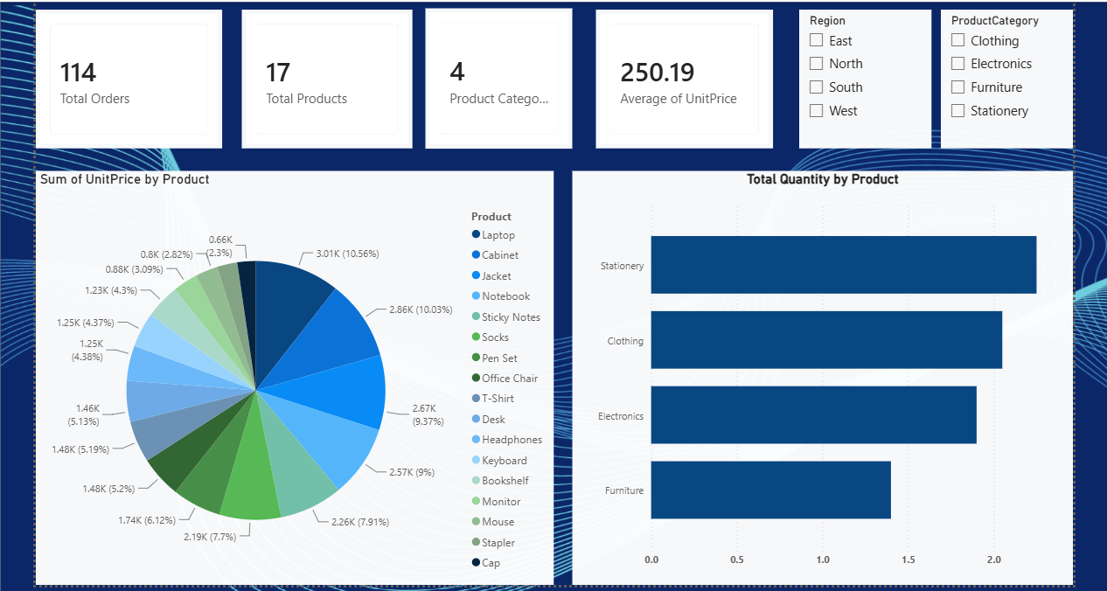

RESULT :

